**EDA OVERVIEW**

Listing the aspects that can be captured through exploratory data analytics from our cleaned data.

Census tables:

[Census tables | Government of India](https://censusindia.gov.in/census.website/data/census-tables)

| **EDA Topic** | **Status** |
| --- | --- |
| Show different occupation classes in all of India | Done |
| ~~Show different states with respect to each occupation to see which state is most invested in that occupation (bubble chart)~~ | Dropped |
| Show migration to different states using (sankey diagram) | Done |
| States that had the most outgoing migration (top 10) | Done |
| States that had the most incoming migration (top 10) | Done |
| Horizontal bar chart for religion distribution (each state on y-axis and persons on x-axis and colours of the bars by religion) | Done |
| Show proportion of all religions in each state and UT | Dropped |
| Show multilingualism using sunburst chart | Done |
| Show different indices for each state | Done |
| Top 10 per index category | Done |
| Top 10 most culturally diverse states | Done |
| Stacked bar chart for showing the different indices per state | Dropped |
| Prevalent religion/occupation/language in each state (geomap graph) | Dropped |

*Insert EDA plots and interpretation under this line*

Different occupation classes of main and marginalised workers in India.

We note that craft and related trade workers have a higher proportion when compared with other occupations.

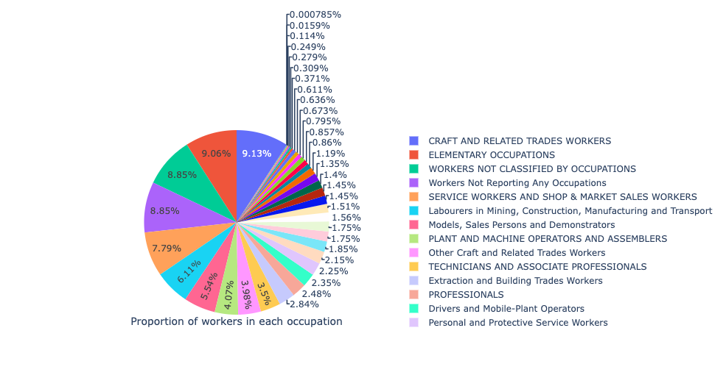

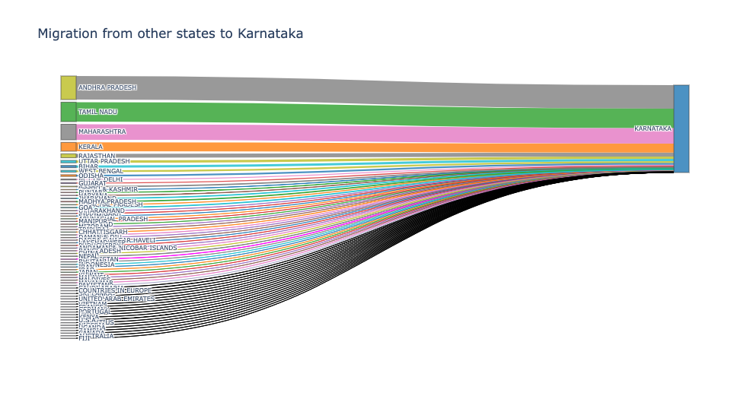

We can see here that the people from Andhra Pradesh have migrated the most to Karnataka when compared to Migration from other states. Then comes Tamil Nadu followed by Maharashtra and Kerala. And the least comes from Fiji.

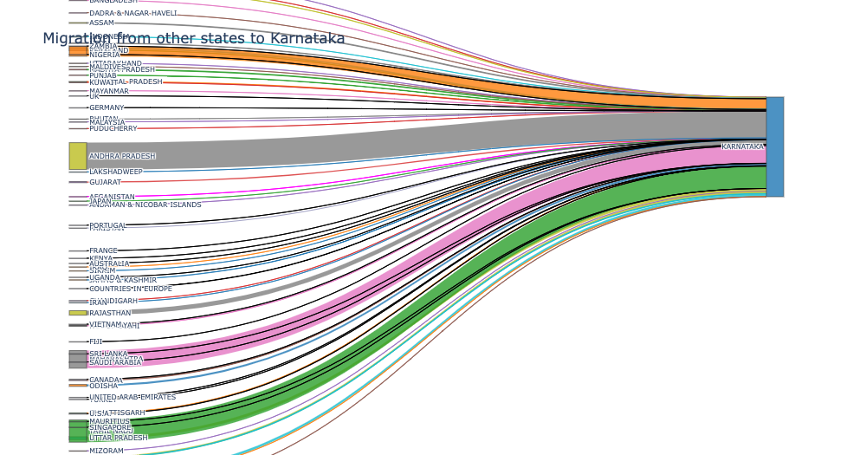

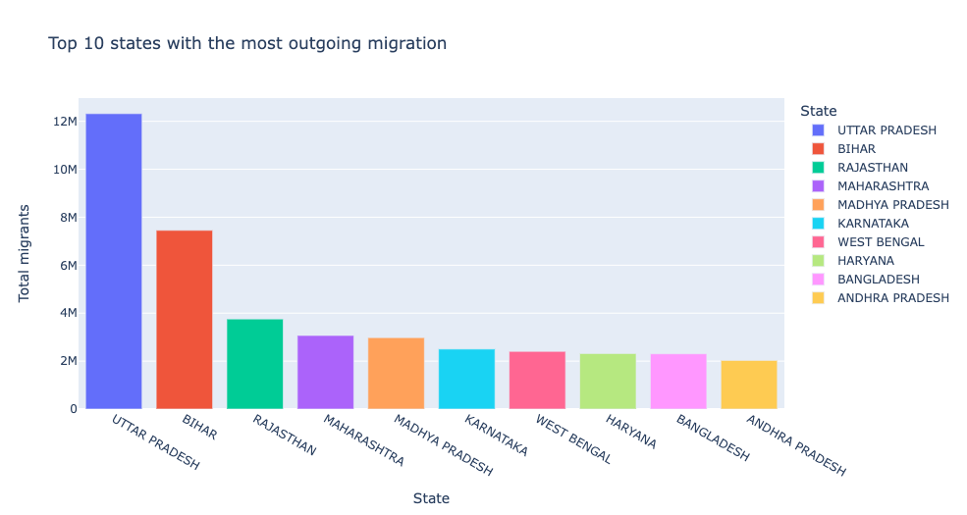

Here, we can see that people from Uttar Pradesh migrate to other places the most in search of Opportunities. The second would be Bihar and then Rajasthan. To the 10th position stands Andhra Pradesh in migrating.

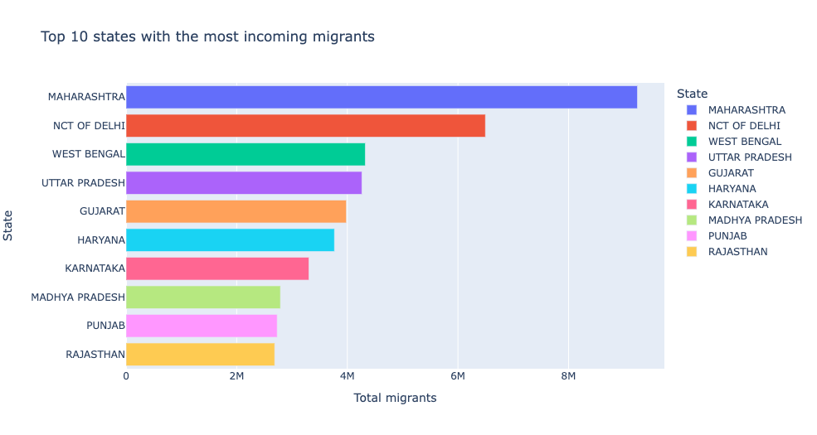

Of the most incoming migrants, Maharashtra stands first. People go to Maharashtra to find the opportunities for better standards of living. The next place people go to is the National Capital Territory of Delhi. With a little difference West Bengal and Uttar Pradesh stand third and fourth respectively. Rajasthan is in the tenth place with a lesser difference with Punjab which is in the Ninth place.

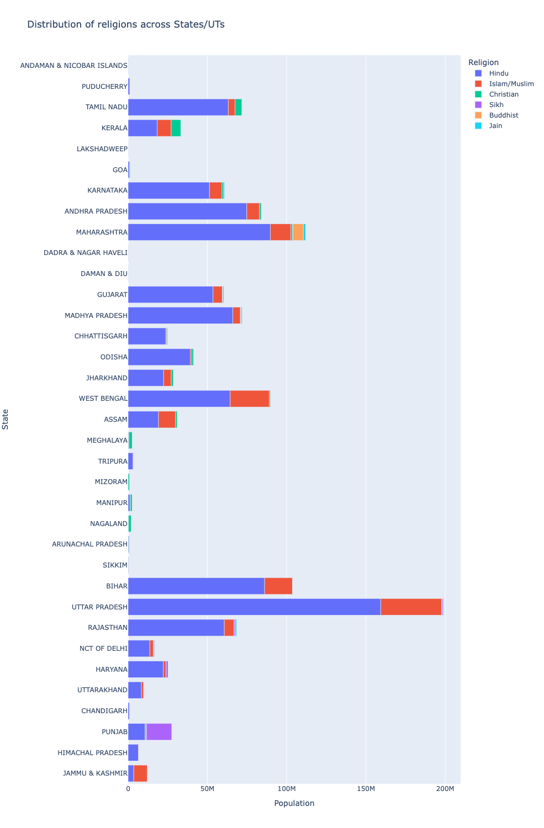

In the Religion distribution among the States and UTs, we can see that the majority of states have Hindus and Uttar Pradesh is the state with more Hindus . Followed by Maharashtra. UP is the same state that has more Islamic people as well. Nagaland is the only place with Christians. And we can see more Christians are from Kerala when compared to other states/UTs. Maharashtra and Punjab are the only places with Buddists. Sikhs are mainly seen in punjab and few in Haryana. Maharashtra and Rajasthan are the places with Jains (also in fewer numbers).

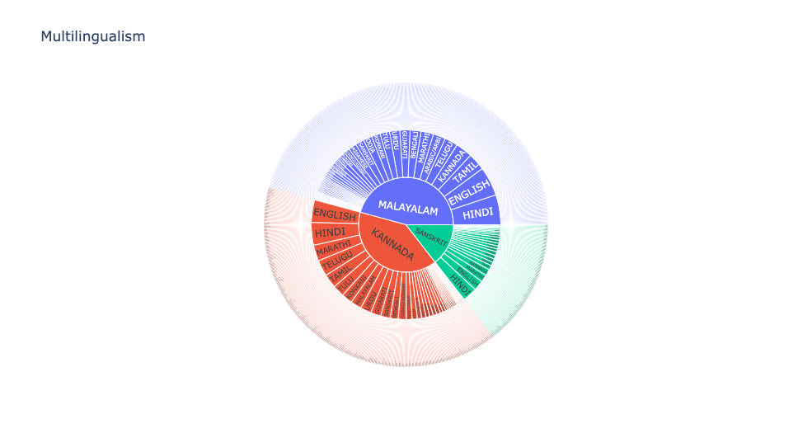

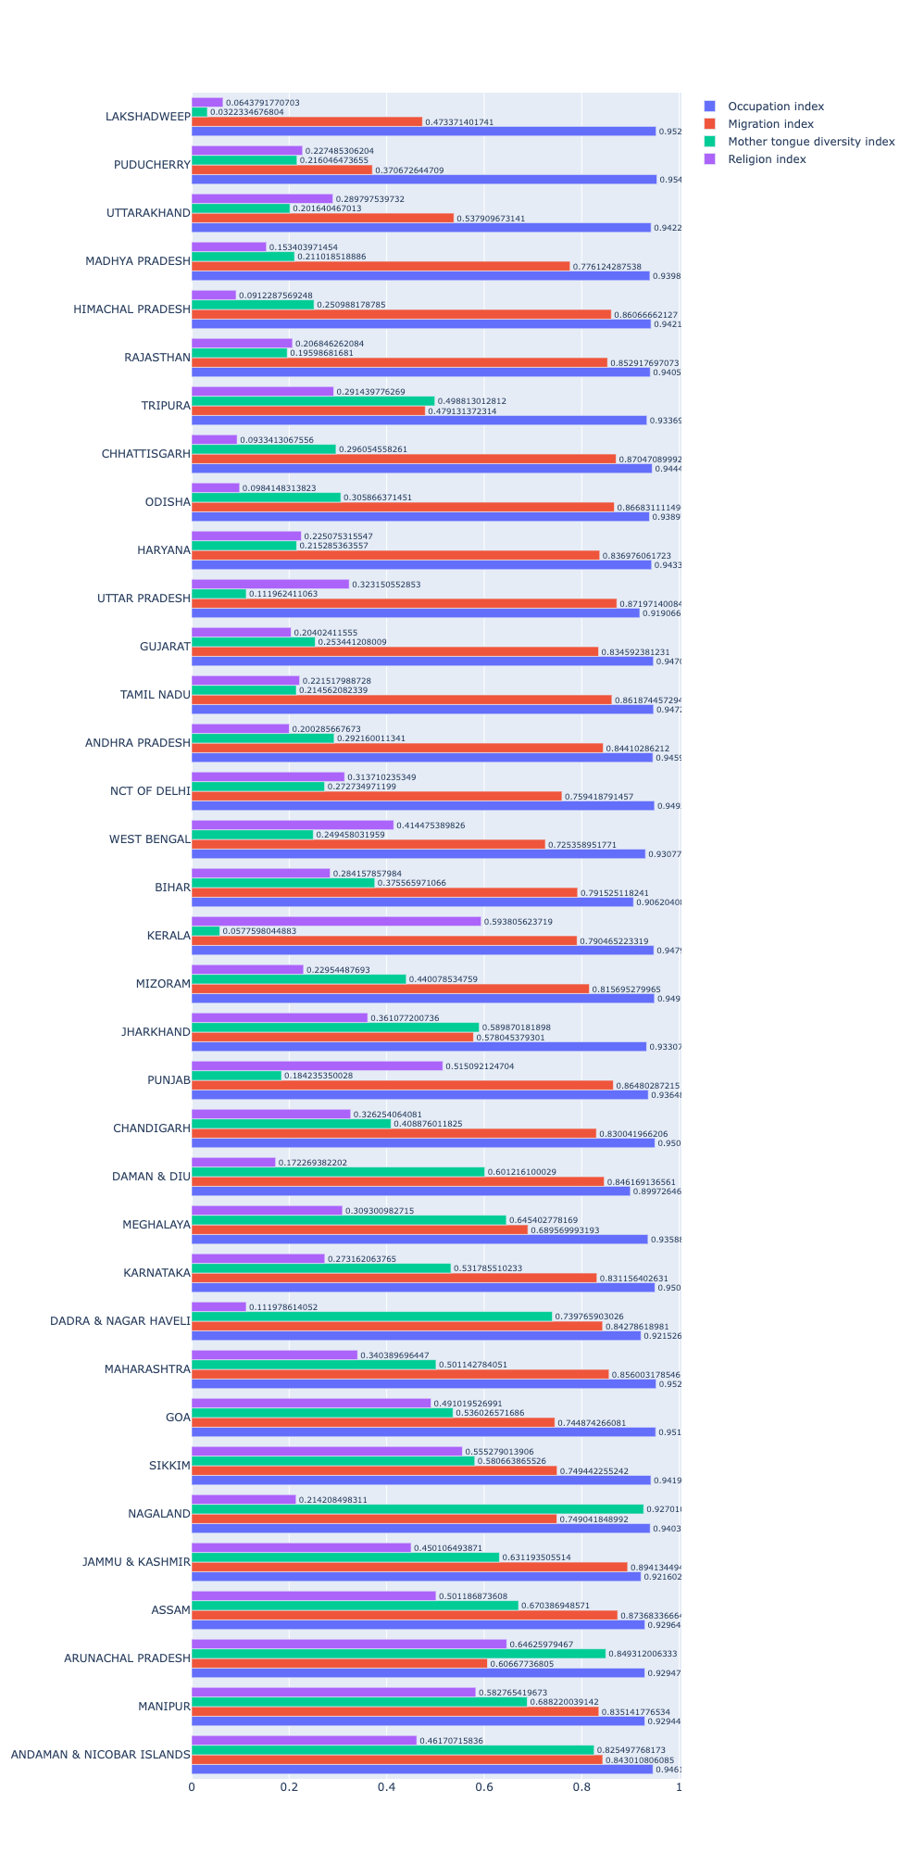

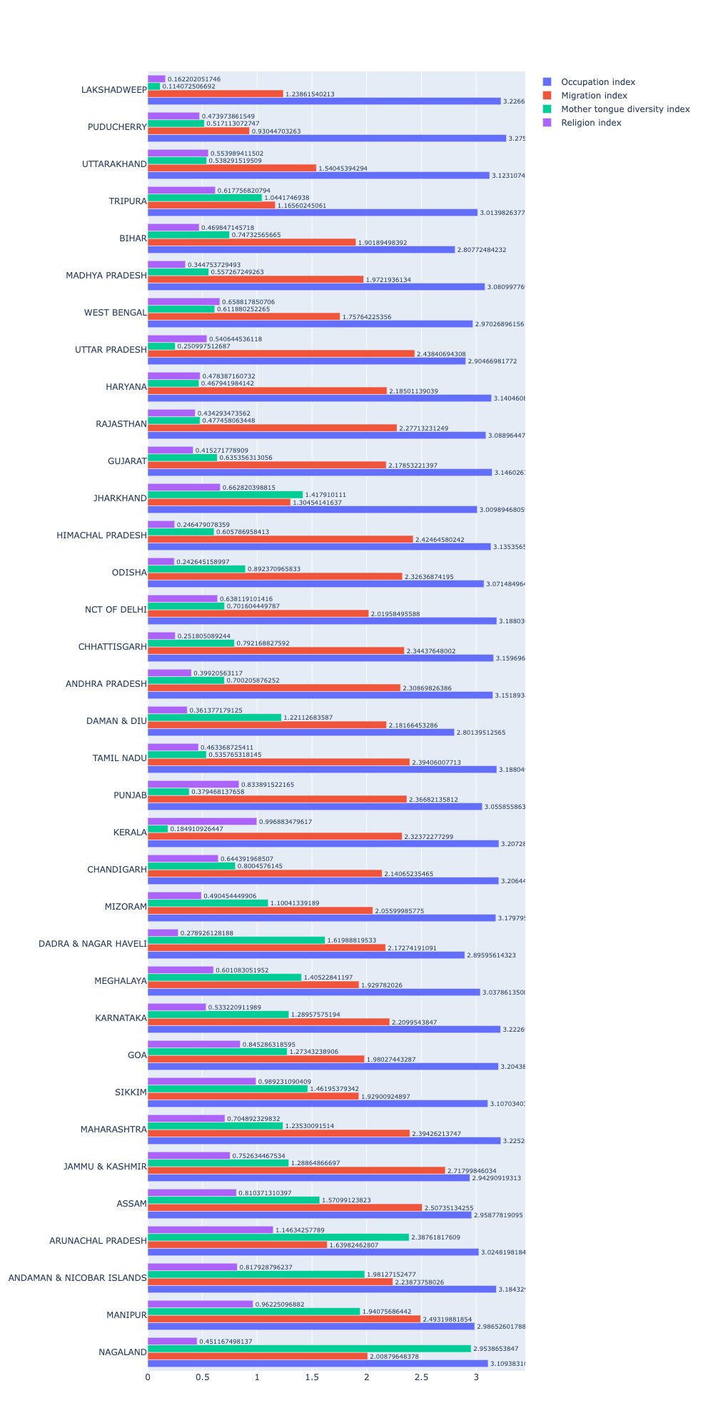

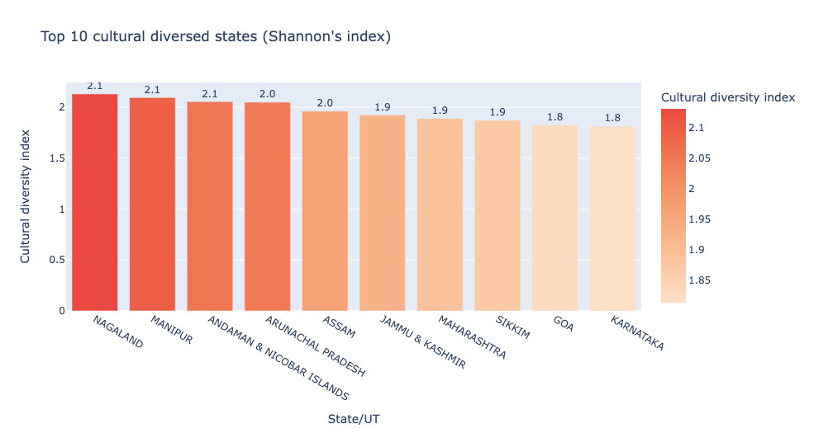

In the top 10 culturally diverse states which was calculated using Shannon’s Index, Nagaland stands first followed by Manipur. And in 10th position is Karnataka.

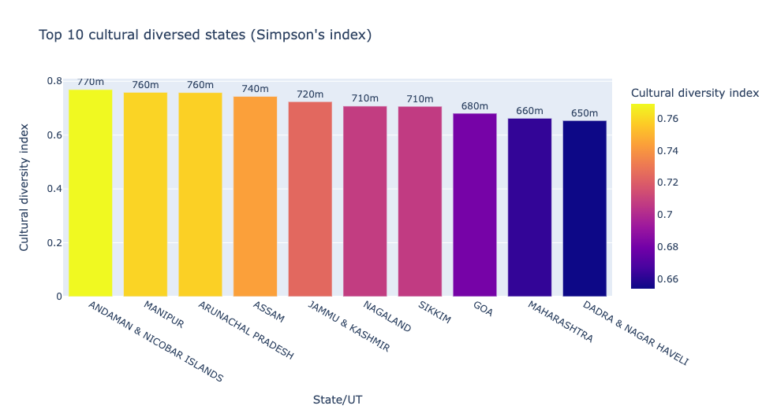

In the top 10 culturally diverse states which was calculated using Simpson’s Index, Andaman & Nicobar Islands stands first followed by Manipur. And in 10th position is Dadra & Nagar Haveli which is the UT.

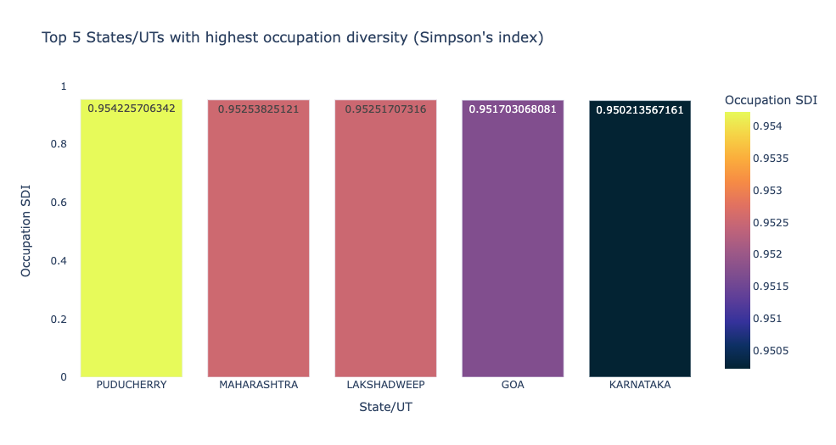

Here we could see that Puducherry stands first in the top 5 in the highest occupation diversity calculated using Simpson’s Index. And in fifth place is Karnataka.

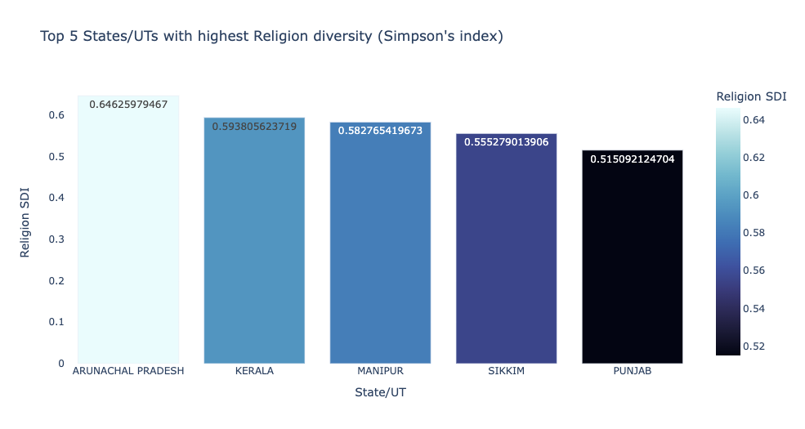

While checking for the highest Religion diversity calculated using the Simpson’s Index, we can see that Arunachal Pradesh in the first and Punjab in the fifth position.

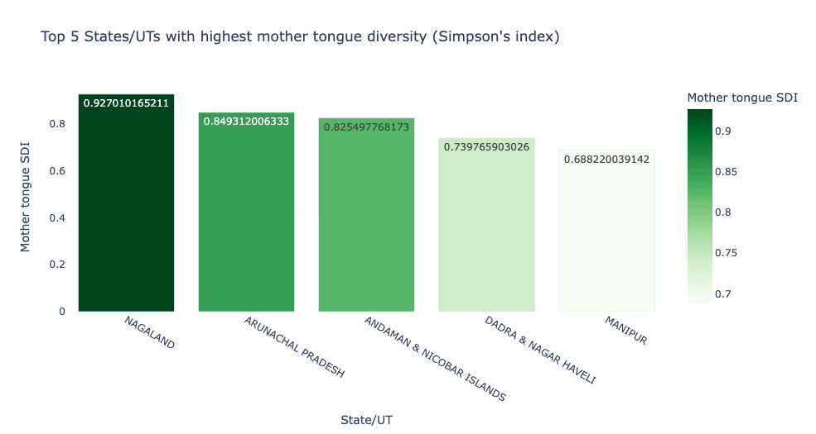

When coming to the highest mother tongue diversity, we can see Nagaland with the most diverse state for mother tongues. And in fifth position is Manipur.

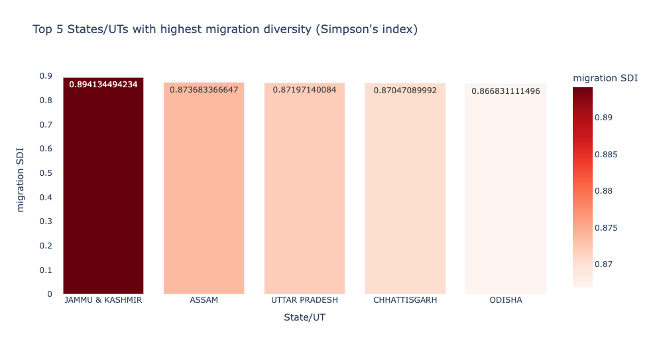

Here, we can see that Jammu & Kashmir has the most diversity in the migration. In the fifth position comes Odisha.

